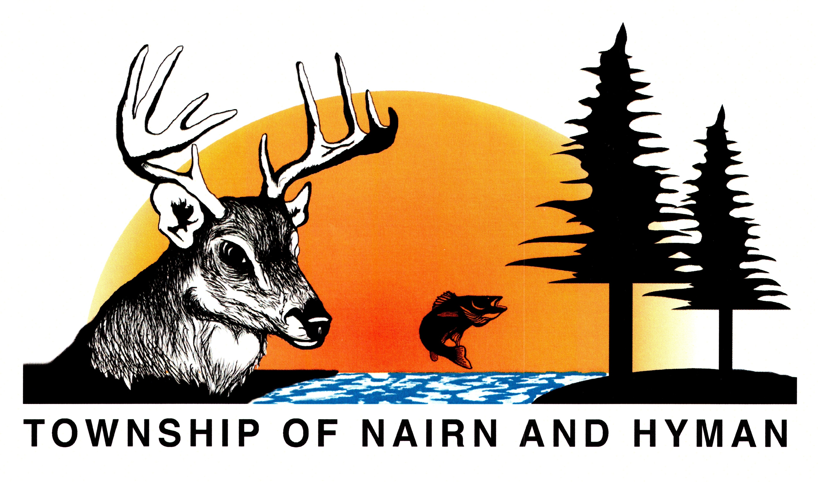

NOTICE OF MEETING

Community Parks and Recreation Committee Meeting:
Tuesday, February 16th, 2021 @ 6:00 P.M.

Due to the Stay-At-Home order issued by the province, this meeting will be held electronically. Members of the public can listen to the meeting live through the Zoom app. To join the meeting please follow the below instructions:

Join Zoom Meeting
https://us02web.zoom.us/j/87614343798?pwd=MDlxYkdtRklLN2c4ckJmY3ltdDB1Zz09

Meeting ID: 876 1434 3798
Passcode: 253983

Dial by your location
+1 204 272 7920 Canada
+1 438 809 7799 Canada
+1 587 328 1099 Canada
+1 647 374 4685 Canada
+1 647 558 0588 Canada
+1 778 907 2071 Canada
Meeting ID: 876 1434 3798
Passcode: 253983

